# AIAC 11.3

K.CHANDRIKAA

2403A51227

B-10

Task Description #1 – Stack class implementation  
Task: Ask AI to implement a stack class with push(), pop(), peek() and  
is_empty() methods

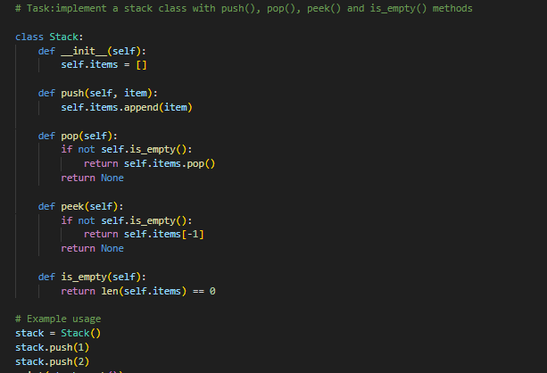

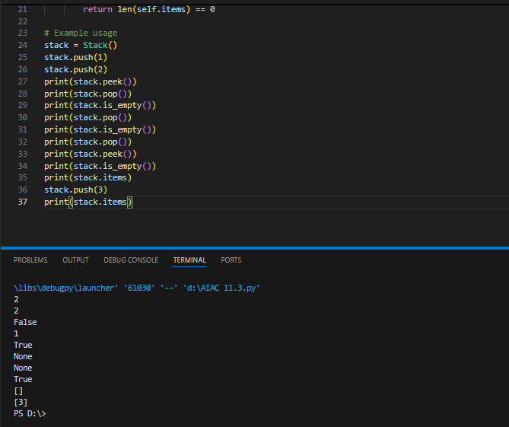

Task 2:

Task Description #2 – Queue Implementation  
Task: Use AI to generate a Queue class with enqueue(), dequeue(), and  
is_empty()

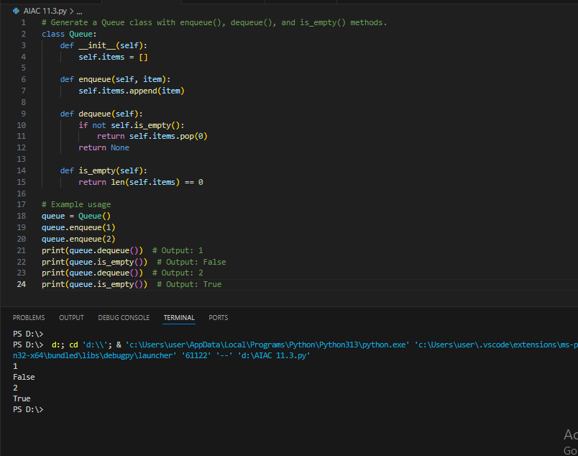

Task Description #3 – Linked List Implementation  
Task: Ask AI to create a singly linked list with insert_at_end(),  
insert_at_beginning(), and display()

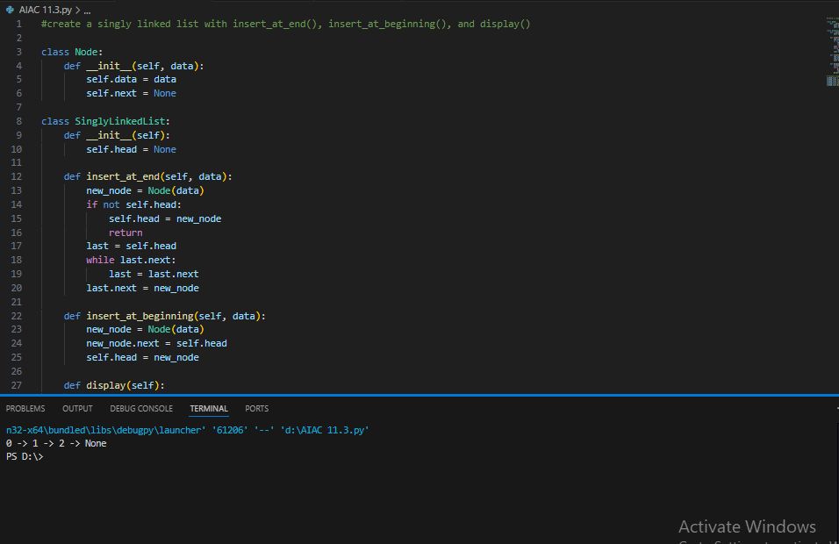

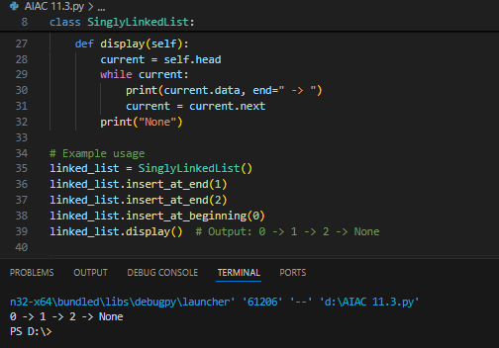

Task Description #4 – Binary Search Tree (BST)  
Task: Ask AI to generate a simple BST with insert() and  
inorder_traversal().

